1. Creating and Renaming Files/Directories
Create a directory named test_dir using mkdir.
Inside test_dir, create an empty file called example.txt.
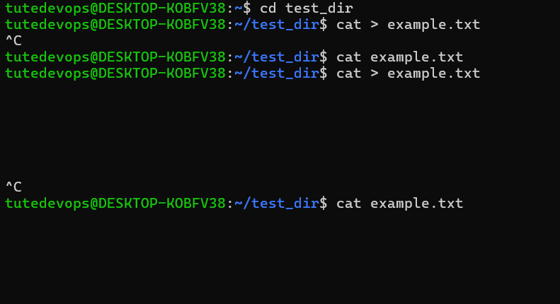
Rename example.txt to renamed_example.txt using mv
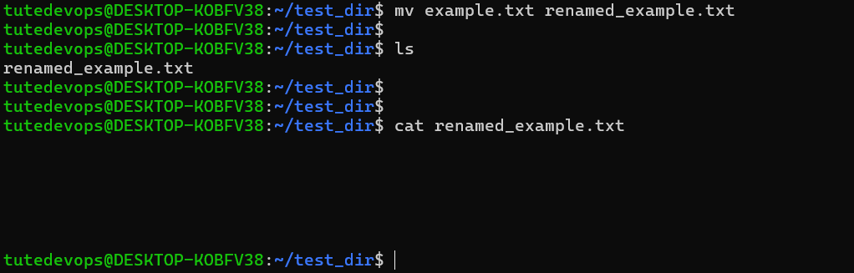
2. Viewing File Contents
Use cat to display the contents of /etc/passwd.
Display only the first 5 lines of /etc/passwd using head : Head displays top lines
Display only the last 5 lines of /etc/passwd using tail: Tail command displays bottom lines
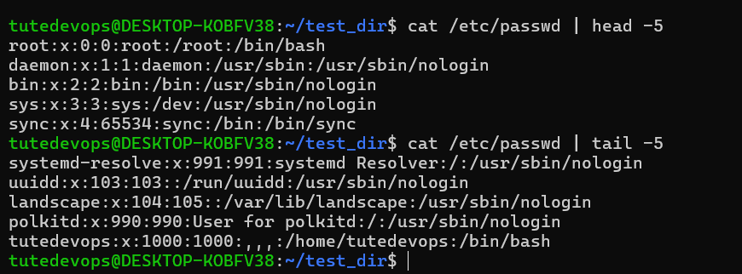

3.Searching for Patterns
Use grep to find all lines containing the word "root" in /etc/passwd.
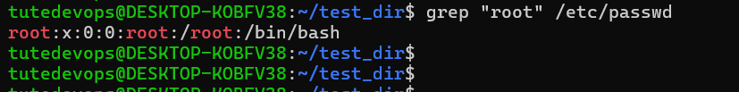

4. Zipping and Unzipping
Compress the test_dir directory into a file named test_dir.zip using zip.
-r : used for recursive zip
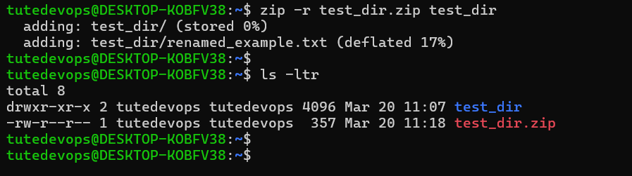
Unzip test_dir.zip into a new directory named unzipped_dir.
Unzipped_dir directory created first and later unzipped directories places in that folder.
-d option used for mentioning destination directory
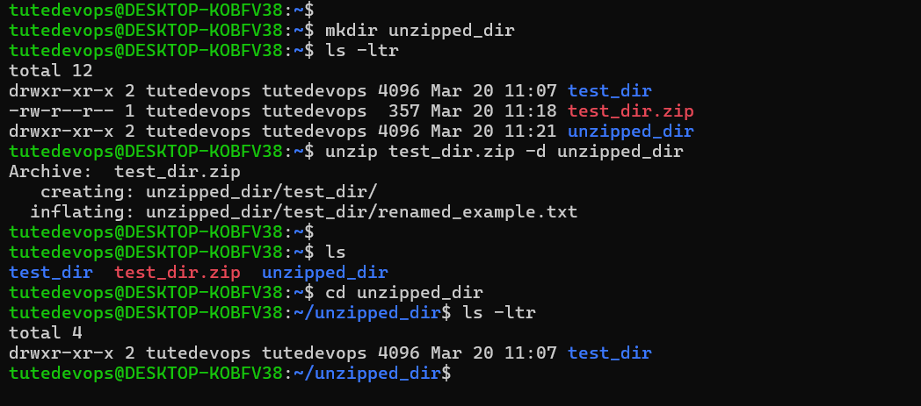

5. Downloading Files
Use wget to download a file from a URL (e.g., https://example.com/sample.txt).
NO file downloaded as no such file exist on given url.
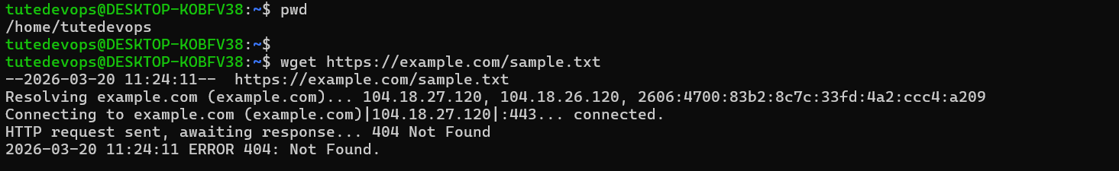
6. Changing Permissions
Create a file named secure.txt and change its permissions to read-only for everyone using chmod.
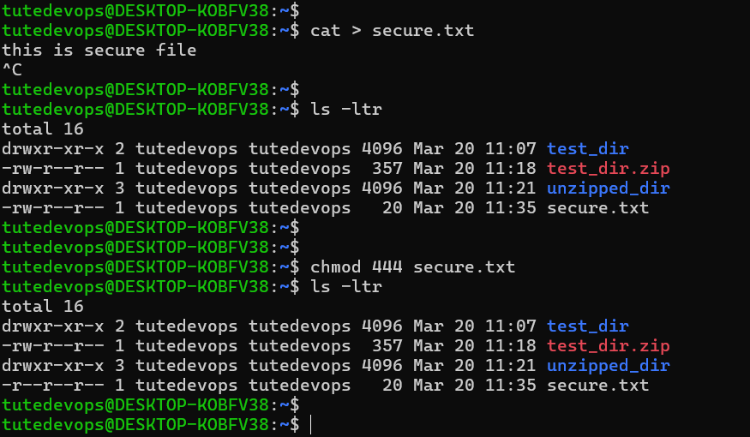

7. Working with Environment Variables
Use export to set a new environment variable called MY_VAR with the value "Hello, Linux!".
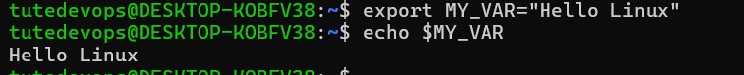
Submission Guidelines -: Attach Screenshots or command along with explanation and submit in doc(google doc or microsoft doc) format also attach github repo link

